EXPERTIMENT NO:32

Design TM using simulator to perform string comparison where w={aba aba}

AIM: To design TM using simulator to perform string comparison where w={aba aba}

INPUT:

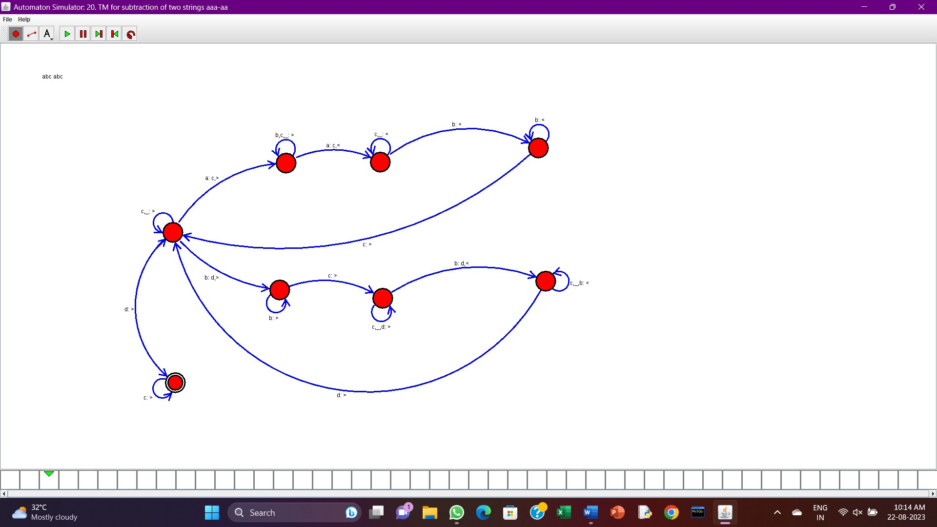

OUTPUT:



RESULT: The program executed successfully and got output.